Unloop Full Stack Web Dev

# String Table Lab

**By completing this lab, you will get experience working with:**

* [String methods and properties](http://www.w3schools.com/jsref/jsref_obj_string.html)
* Inputting code inside [Functions](http://www.w3schools.com/js/js_functions.html)
* Basic DOM manipulations
  + [getElementById](http://www.w3schools.com/js/js_htmldom_methods.html)
  + [innerHTML property](http://www.w3schools.com/js/js_htmldom_methods.html)
* Saving and calculating variables

Your task in this lab is to use JavaScript String methods and properties to fill in a HTML table. The first column displays the String you will be making your calculations based on. The second column displays the method you should use to display the output. The third column will display the output from the String method that you calculated inside your JavaScript function.

## Your website will initially look like this. Note that all rows except the first are missing the output column value. It is your task to calculate and display it.

## Your task is to make the table look like below:

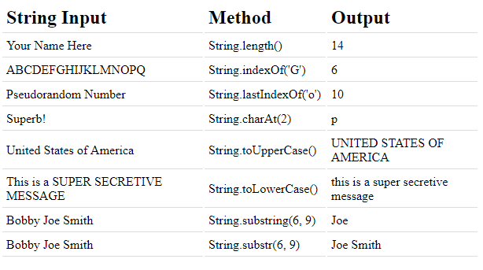

To do this, you will fill in the JavaScript functions that correspond to each row. Reference the code inside the first row’s calculation.

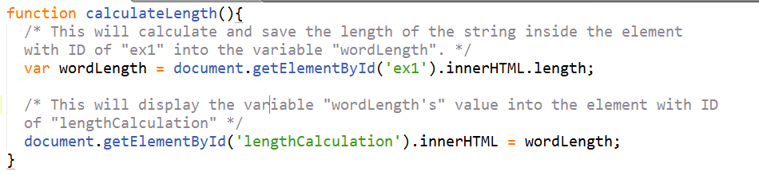

*Each function will contain very similar code.* The main changes you will make are to the values passed in to the DOM method getElementById(), and the string method used to calculate your variable’s value. See the second row’s calculation below:

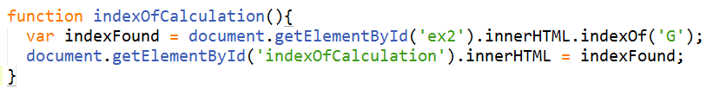

**Color Key:**

**Purple** = variable you are saving your String calculation to. Make sure to give this a descriptive name.

**Green** = ID of the first column you are grabbing its String from

**Red** = String function you are using in this row

**Yellow** = ID of the third column – where you will be placing the output of your calculation.